**Season Recap: 2017**

With the 2017 DKEheads fantasy football season in the books, it’s time to reflect on a record-breaking campaign. We’ll delve into the good, bad, and the ugly (mostly ugly). It was a season of extreme highs and lows, featuring arguably the greatest and worst teams in our league’s six-year history.

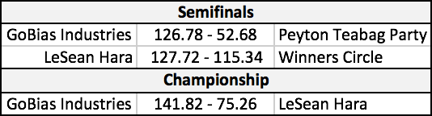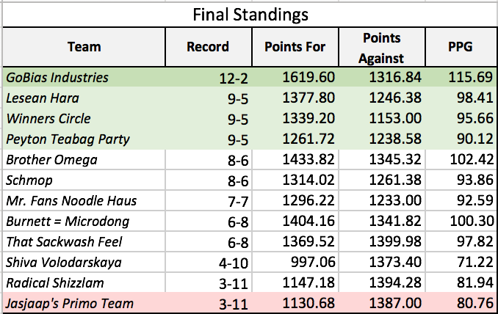

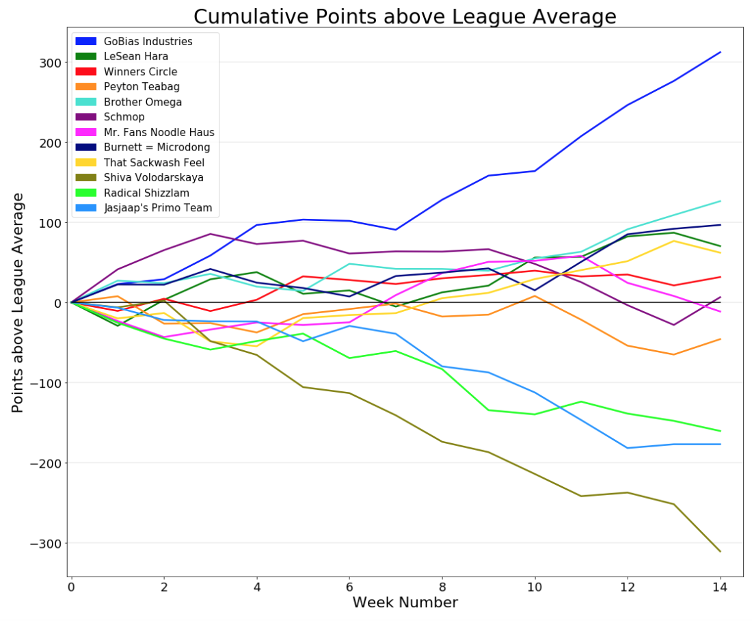

The black horizontal line represents the league (mean) average in cumulative points at a given week. For example, at the end of Week 4, GOBias Industries had 456.50 total points when the league mean was 359.92, so he was 96.58 points above average.

**GObiAs indusTries (GOAT?)**

As illustrated in the plot above, Schulwolf’s team humiliated the competition this year. The gap in points between GOBias Industries and the No. 2 team (Brother Omega) was larger than the gap between the No 2. and No. 9 (Peyton Teabag Party) teams. From Weeks 8-14 (the entire second half of the season), GOBias Industries averaged 127.66 points per game, and posted the highest score in the league in six out of seven weeks.

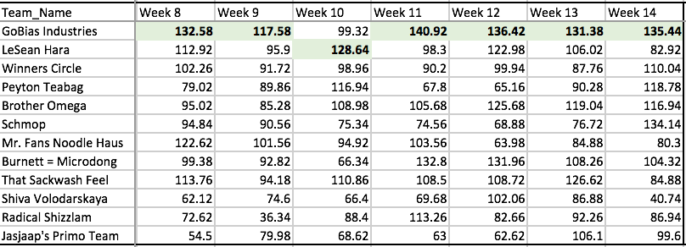

Weekly Scores, Weeks 8-14

GOBias Industries then rolled through the playoffs, defeating Kitchell’s Peyton Teabag Party 126.78 - 52.68 in the semifinals and Eli’s LeSean Hara 141.82 - 75.26 in the finals. By almost every metric, GOBias Industries was the strongest team in league history.

Top 10 Teams in League History (by Total Points)

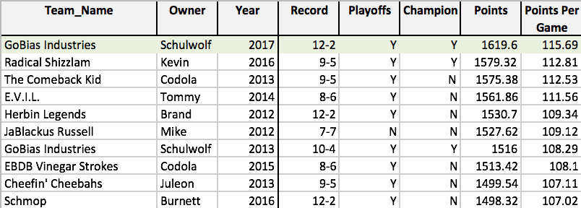

Schulwolf’s campaign was particularly impressive given that league-wide scoring declined significantly in 2017. Fantasy teams scored an average of 93.4 points per game (PPG) this season, down considerably from previous years. The primary reason for this decline? Likely poor quarterback play/injuries in the real NFL.

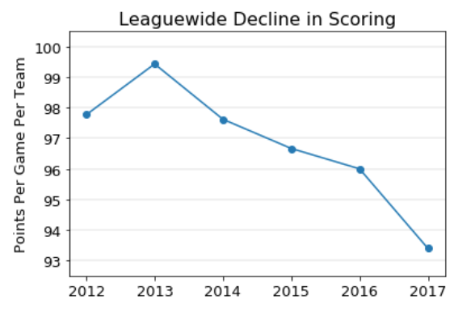

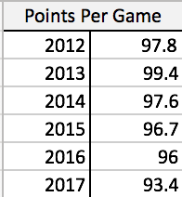

**The Playoff Hunt: “Best of the Rest”**

The head-to-head nature of fantasy football means that the four teams that qualify for the playoffs are rarely the four best teams. This year was no exception. Schulwolf and Eli deserved their spots, but Cam’s team (Winners Circle) was average and Peyton Teabag Party was one of the weakest playoff squads in recent memory. Here’s how the four playoff teams compare to contenders from past seasons:

**Playoff Teams Ranked by 1) Points and 2) Points Relative to League Average**

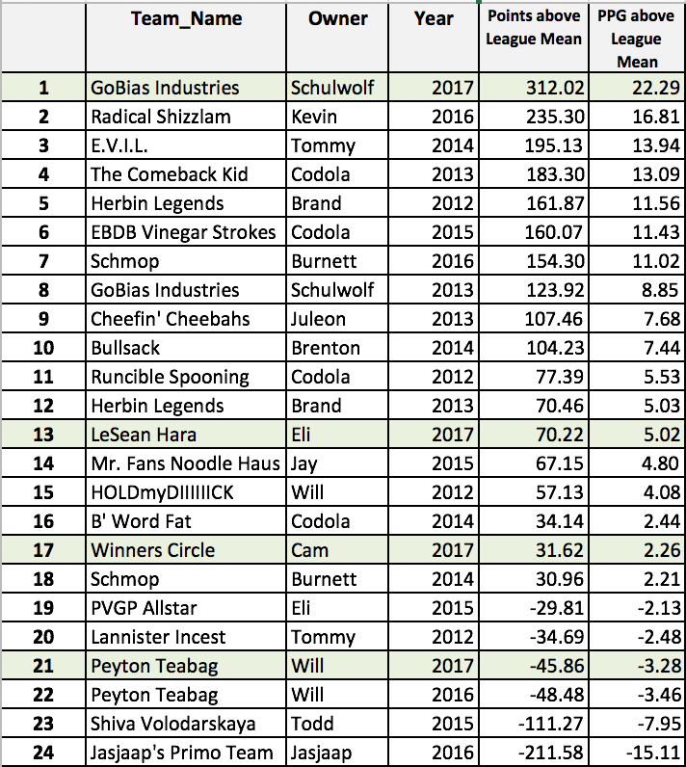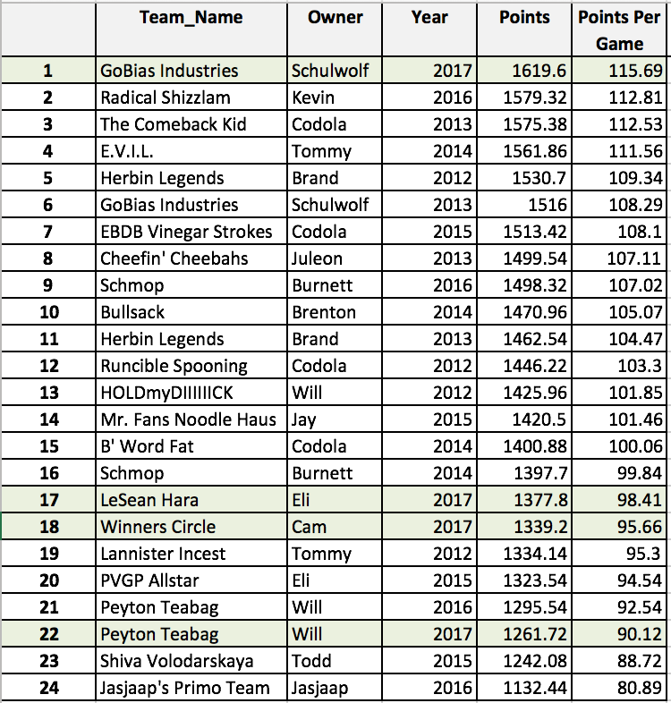

A few takeaways:

* Aside from GOBias Industries, this year’s playoff field was fairly mediocre.
* Jasjaap’s playoff team in 2016 was truly atrocious.
* This isn’t a popular narrative, but Codola dominated the league from 2012-2015, qualifying for the playoffs each year.
* Jacobson has never qualified for the playoffs (!) – largely due to bad luck.

After his playoff-clinching win in Week 14 (which knocked me out of contention), Kitchell ~~taunted~~ asked me to run a statistical analysis of how much his team deserved to make the playoffs. To evaluate the merit of his playoff appearance, I re-ran 100,000 simulations of the season. I assumed that each team’s weekly score was normally distributed based on the mean and standard deviation of their regular season scores.[1] I actually ran two rounds of simulations: 1) a “regular” simulation of the 14 week-by-week matchups and 2) a “fair” simulation with the same matchups from Weeks 1-11 but randomly selected matchups from Weeks 12-14. The second chart is a better proxy for evaluating whether a team “deserved” to make the playoffs because it controls for strength of schedule. The results are below:

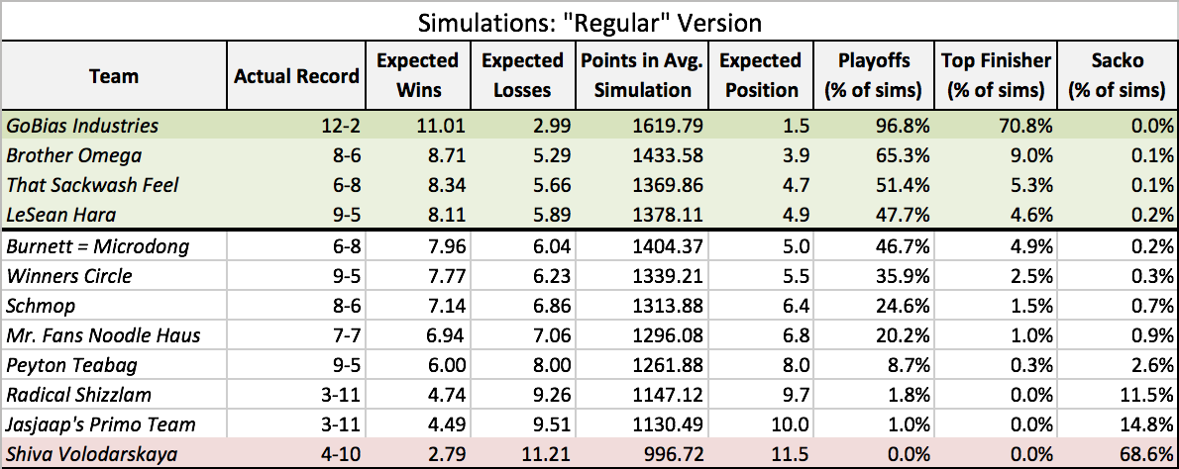

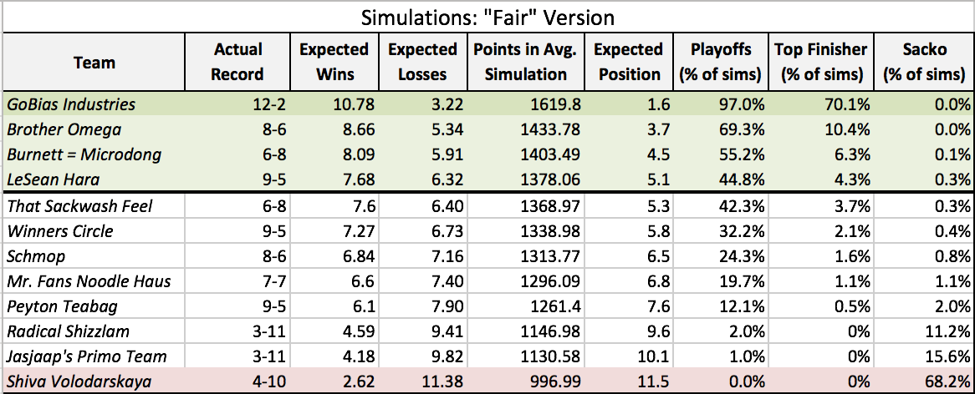

Observations:

* Kitchell qualified for the playoffs in 12% of simulations under the “Fair” scenario, which is actually higher than my initial prediction of “sub-10%”.
* Brother Omega made the playoffs in roughly two-thirds of simulations, but failed to qualify in the real season.
* Despite faring well in the simulations, B urnett = Microdong and T hat Sackwash Feel finished in 8th and 9th place in the real season.
* On paper, T hat Sackwash Feel had one of the easiest schedules in the league, facing Jasjaap’s Primo Team, Shiva Volodarskaya, and Schmop twice. (This explains why Tommy’s playoff chances are considerably higher in the “Regular” scenario versus the “Fair” scenario). Bizarrely, however, Tommy ended up facing the toughest schedule in the real season, as his opponents averaged 100.0 points per week against him (tops in league).
* The simulations might slightly underestimate Winners Circle because they don’t account for Cam’s strong playoff performances (115.34 and 112.26 points in two games)
* You might argue that the percentage for GOBias Industries finishing at No. 1 should be higher than 70% of simulations. Why only 70%? These models implicitly consider the idea that Schulwolf’s (or any team’s) performance this season may not be a true reflection of the team’s actual strength. For example, is Todd Gurley good enough to score 20 points per game in every season? Probably not.
* Shiva Volodarskaya finished in 12th place in 68% of simulations. Todd is very lucky that he doesn’t need to take the ACT…
* Given how poorly Todd’s team played, Jasjaap was unfortunate to get the Sacko, as he finished rock bottom in only 15% of simulations. Amazingly, Jasjaap scored nearly the same number of points (1130.68) in 2017 as his playoff-bound team in 2016 (1132.44). Talk about regression to the mean. Happy studying!

**Burnett’s Midseason Collapse**

At the 3-week mark, it looked like Burnett’s team (not Schulwolf’s) would be in the running for best team in league history. Bolstered by Kareem Hunt’s sensational start, Schmop was just the second team ever to score over 110 points in each of the first three games. (Funnily enough, the only other team to accomplish this feat was Schmop in 2016). However, Burnett followed this fast start with a 10-game stretch of stunning ineptitude, failing to reach 100 points in each of the next ten weeks. Schmop posted an impressive score in Week 14, but it was “too little, too late” to salvage a once-promising season.

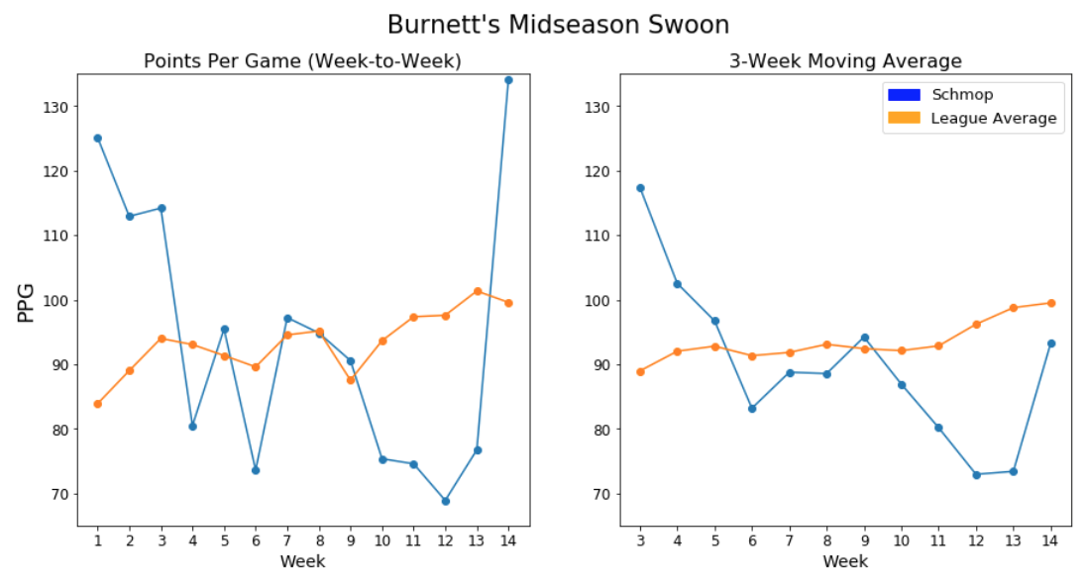

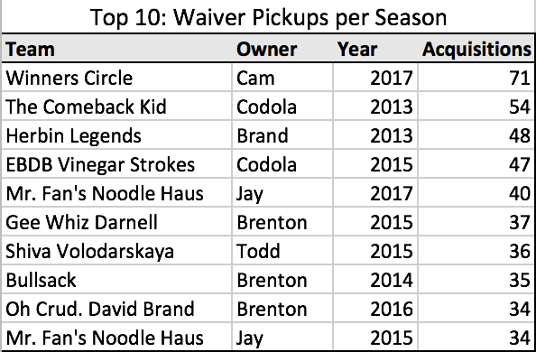**Cam’s Waiver Wire Madness**

Having missed the playoffs in his first two years in the league, Cam was determined to change the script in 2017. He was by far the most engaged owner in league history, making 71 waiver wire moves. The persistence paid off, as almost 60% of Winners Circle’s total points (906.14 of 1566.80) came from post-draft acquisitions.

**Bottom of the Barrel**

The league saw three unusually poor teams this year, each scoring less than 82 points per game. I won’t be too harsh in this section but will let the numbers speak for themselves. Shiva Volodarskaya was unfortunate to lose David Johnson in Week 1, but…yeah just look at the charts below.

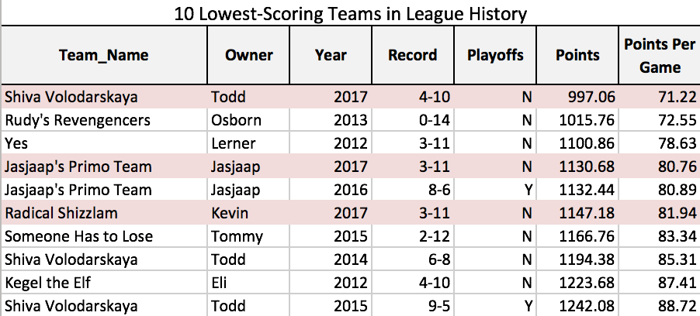

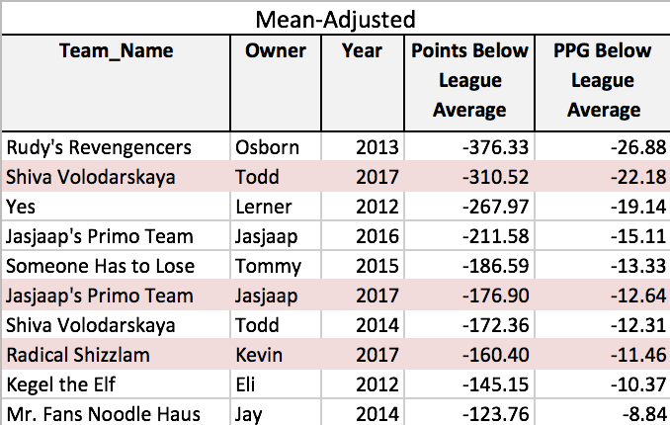

1. The normal distribution is actually a decent assumption for describing the probability distribution of team-level fantasy points. For most teams, the mean and median scores over 14 games were relatively equal (so distribution is symmetric). The standard deviations for most teams were around 18-20 points. Interestingly, scores outside +/- 1 standard deviations were more common than expected (37% vs. 32%), but scores outside +/- 2 SDs almost never occurred (however this was only tested on a small sample size).